Table of Contents
1 Overview 2
2 Simplified Logical Applications Access 2
3 Automated Access 2
4 Birthright Access 2
5 Business Application Access 2
6 Privileged Application Access 3
7 Mover Lifecycle Event Priority 3
8 Mover Persona 3
9 Process Joiner After Mover 3
10 Process Attribute Synchronization Before Mover Certification 3
11 Mover Certification Options 4
12 Mover Certification Configuration 4
13 System Certification Item Rule 10
14 Application Inclusion 10
15 Before Mover Certification 10
16 Before Mover Only Primary Account 11
17 Certification Exclusion Rule 11
17.1 Algorithm of Exclusion Rule 11
18 Mover Process 11
19 Automated Mitigation Process 12
20 Mitigation Manager Notification 12
21 Mover and Automated Mitigation Data Flow 12

.
Document Revision History
Version | Date | Status | Author | Summary of Changes
Version 1 | 3/2/18 |  | Rohit Gupta
Version 2 | 4/4/18 |  | Cathy Mallet | Minor grammar/spelling/etc edit

Overview
The purpose of this document is to explain Mover Feature that is built within the Accelerator Pack. This feature requires some configuration in IdentityIQ for email templates, notification schemes and simplified logical applications. Those configurations are outlined in the Accelerator Pack Implementation Guide.

Simplified Logical Applications Access
There are three ways logical applications can be managed in IdentityIQ
- Logical Connector
- Roles
- Extended Attribute
Accelerator Pack leverages extended attributes on roles and entitlements to manage logical applications. As a result, a custom artifact is used to include/exclude logical applications during ad-hoc or scheduled certifications. The logical applications originate from Infrastructure/Technology applications. The internal name of the “Logical Business Application Name” attribute on the role is “appName” and on entitlement is “entAppName”.

Exclusion of these applications can be configured using the Accelerator Pack “Global Definition” QuickLink.

Note: Multiple business application names can be stored on Infrastructure/Technology roles/entitlements using a comma separator. This is a use case where an entitlement or role is being shared across Infrastructure/Technology applications. This is mostly seen in case of technologies with multiple instances.

Automated Access
This access is assigned in IdentityIQ using assignment rule. All the Identity Role assignments are interrogated and any role assignment coming from source “Rule” will be excluded from the mover certification.

Birthright Access
This is a simple true or false value attribute on the Entitlement extended attribute “isBirthright” and the Roles extended attribute “isBirthright”. During the mover process, birthright access associated with applications is excluded from the mover certification.

Business Application Access
This is a simple true or false value attribute on an application named “Is Business Application”. During the mover process, all access associated with the business application is included on manager certification, as compared to Infrastructure/Technology applications.

Privileged Application Access
This is a simple true or false value attribute on the Entitlement extended attribute “entPrivileged” and Roles extended attribute “rolePrivileged”. During the mover process, privileged access associated with applications can be excluded from the mover certification. This exclusion can be configured using the Accelerator Pack “Global Definition” QuickLink.

Mover Lifecycle Event Priority
The Joiner, Joiner Rehire, Leaver, and Attribute Synchronization Lifecycle Events has priority over Mover. In case an identity is eligible for joiner or rehire or leaver or attribute synchronization Lifecycle Event, Mover Lifecycle Event will not be kicked off.

Mover Persona
When persona feature is enabled, Mover process gets kicked off either when personas are dropped for an Identity or based on Lifecycle Event Triggers. Drop of personas are calculated based on Identity’s “relationships” attribute. Sample rule “Rule-Framework-IdentityAttribute-Relationships” packaged with Accelerator Pack must be used as a reference to define personas on an identity. Here is an example of personas that are dropped from an identity. Either keyword [INACTIVE] or deletion of persona on “relationships” attribute is considered as persona drop.

Identity Relationships
EMPLOYEE [ACTIVE] (FTE1)
EMPLOYEE [ACTIVE] (FTE2)
STUDENT [INACTIVE] (100-Health Science-RIT) -> Dropped Persona

Note: Mover Certification Name will contain dropped persona name

Process Joiner After Mover
If this option is checked for an application, joiner access gets recalculated per application. Joiner access is assigned/unassigned to an identity after mover campaign generation.

Process Attribute Synchronization Before Mover Certification
By default, Attribute Synchronization has priority over Mover Lifecycle Event. As a result, this option provides flexibility to run attribute synchronization before mover campaign. If this option is checked for an application, attribute synchronization process per application is executed before mover campaign generation. This process is synchronous. This means any failure will exit the mover workflow and no campaign is generated. An error email will be sent out to Operations team on the failure

Note: Attribute Synchronization can be executed in parallel with Mover Lifecycle Event. This can be configured using Global Definitions option “Mover and Attribute Synchronization Parallel Processing”. If this option is checked at global level, then there is no need to check “Process Attribute Synchronization Before Mover Certification” per application.

Mover Certification Options
Mover certification can be kicked off using two options. Both options are mutually exclusive.
Lifecycle Event
  - By Default, it is enabled
  - Workflow Based
  - Uses Certification Settings from Disabled Certification Event and Custom Object
  - Uses Application Before Mover options
    - Do Nothing
    - Before Mover Certification Options
    - Before Mover Extended Rule
    - Before Mover Only Primary Account
- Certification Event
  - By Default, it is disabled
  - Certification Event Based
  - Uses Certification Settings from Enabled Certification Event
  - Application before mover options are not supported

Mover Certification Configuration
For a LifeCycle Event, the native change certification notification scheme, email templates, and certifications settings are picked up from a certification event “MOVER CERTIFICATION EVENT” and custom object “Custom-Mover-Settings”. In case of Certification Event, custom object is not used.

Please see below table for “Custom-Mover-Settings” Custom object settings that are packaged with this feature. By default, staging is enabled for mover certifications.
.

Key Name | Category | Default Value
certificationNamePrefix | Certification Name | “Mover Event For” (Identity Name is Prefixed)
certificationNameSuffix | Certification Name | “Assigned To” (Manager Name is Prefixed)
stagingEnabled | Staging | True

Please see below for “MOVER CERTIFICATION EVENT” CertificationDefinition object screen shots that are packaged with this feature.

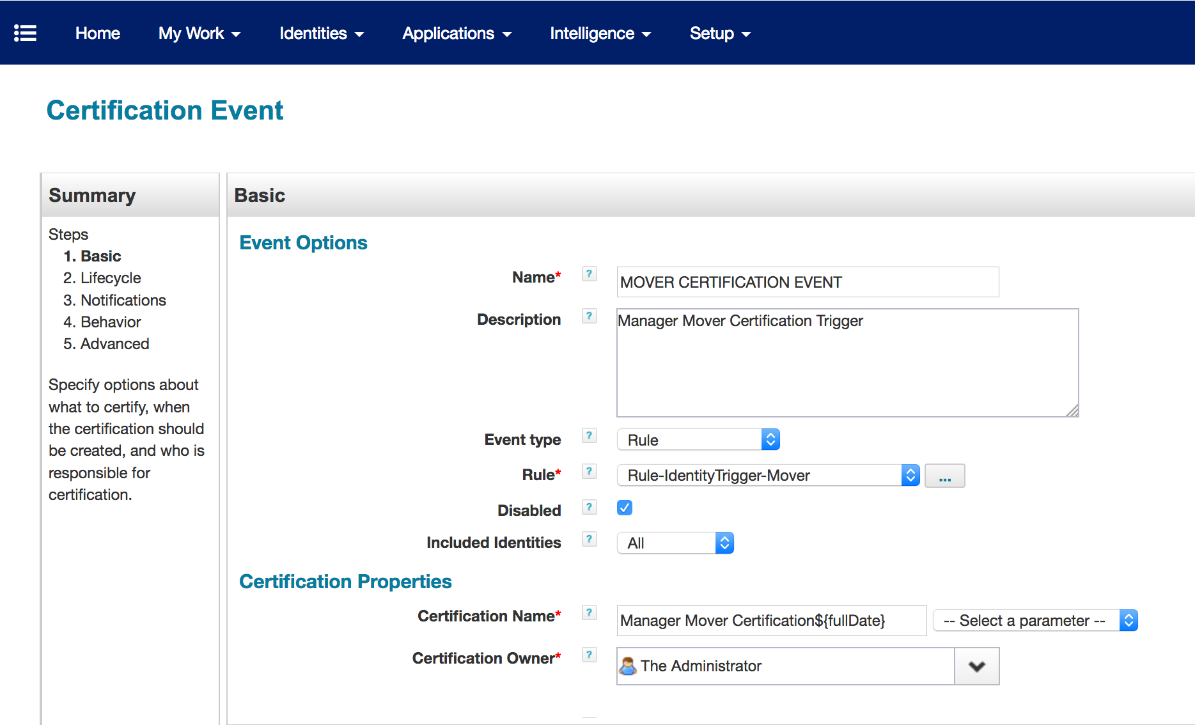

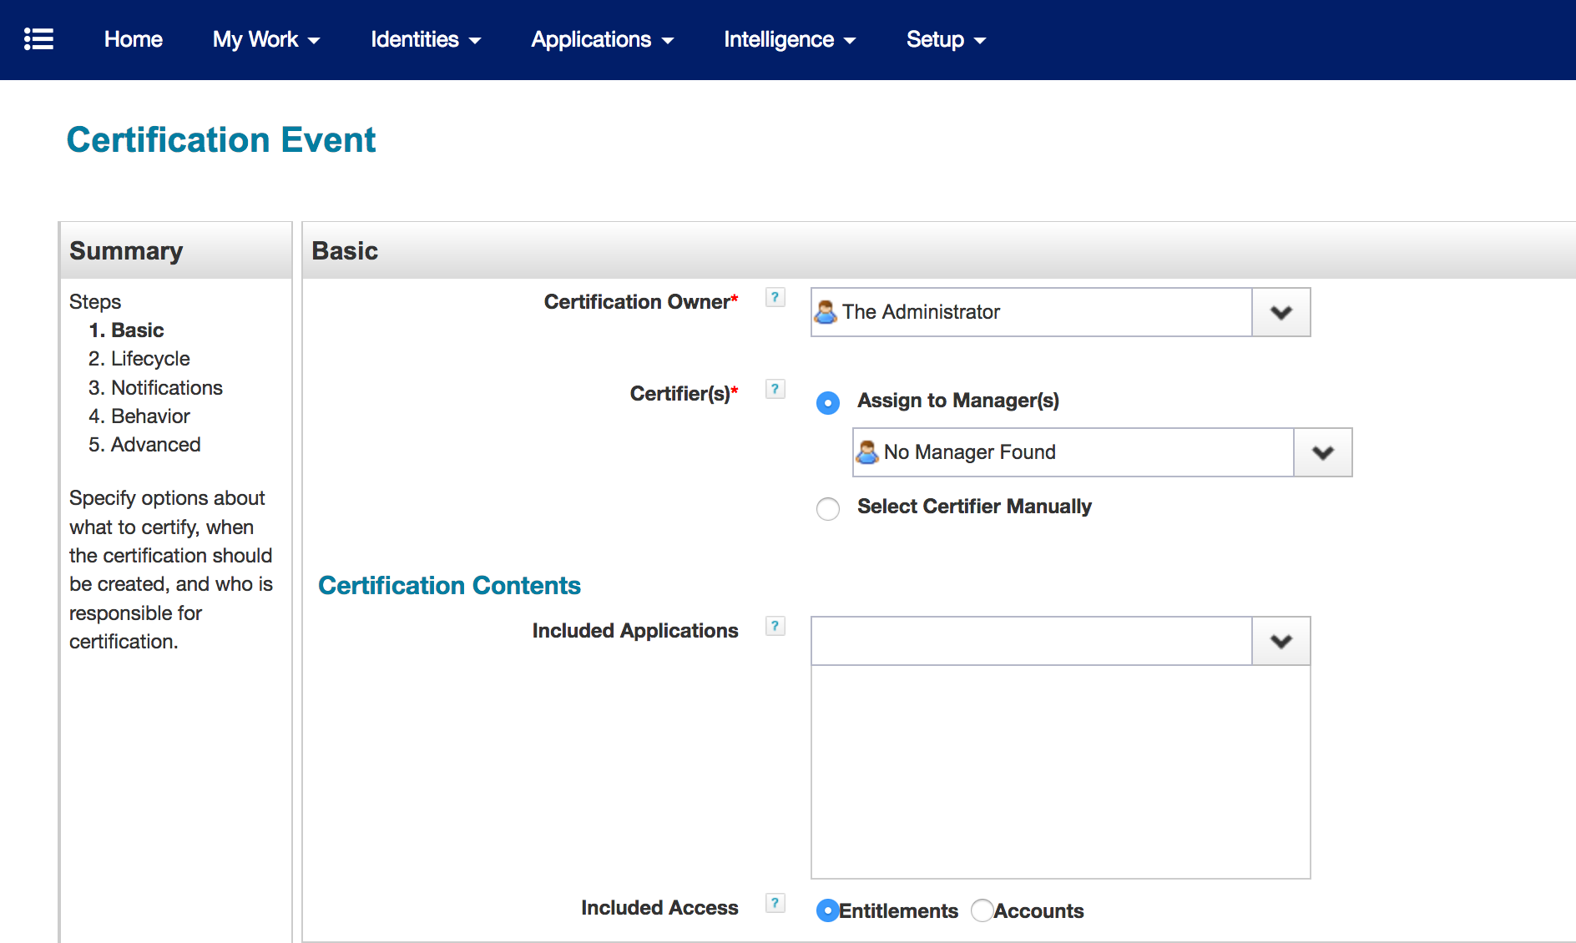

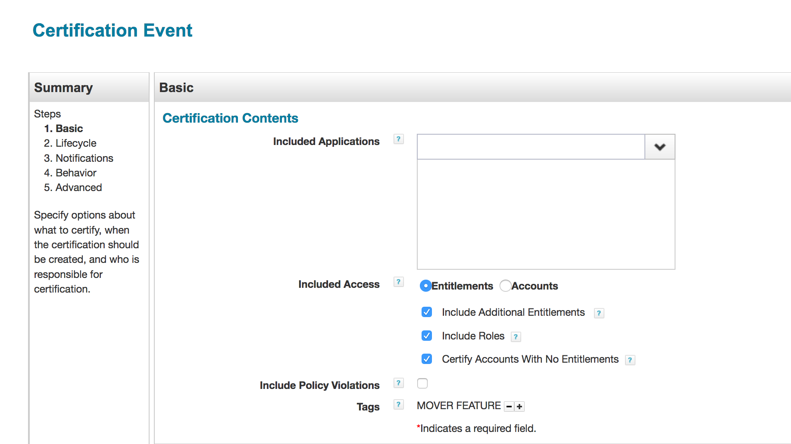

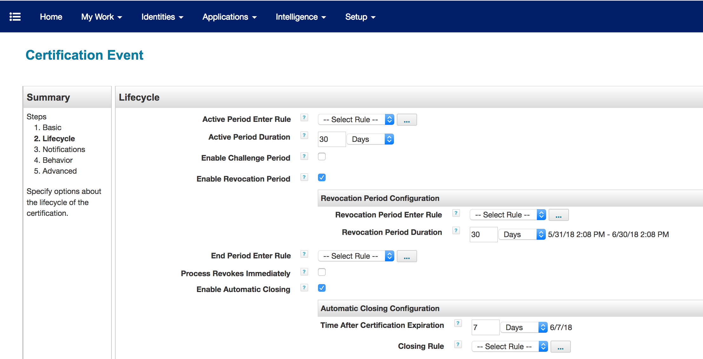

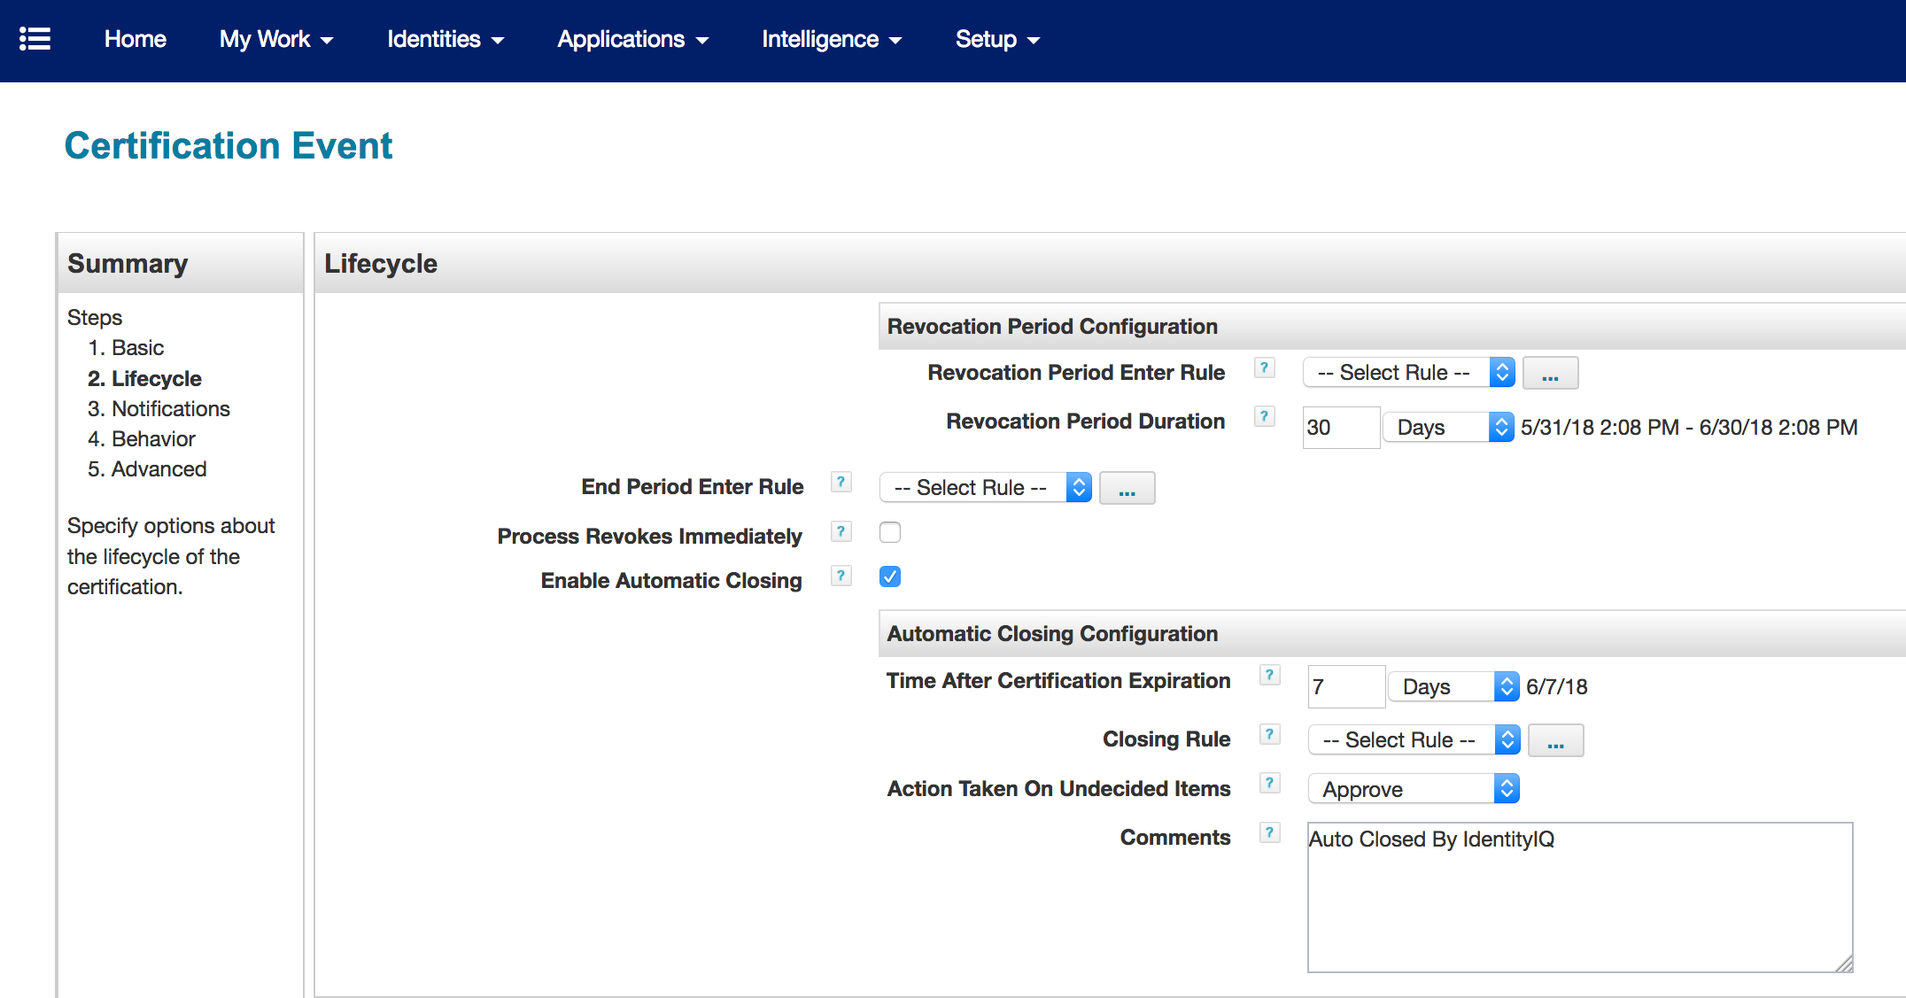

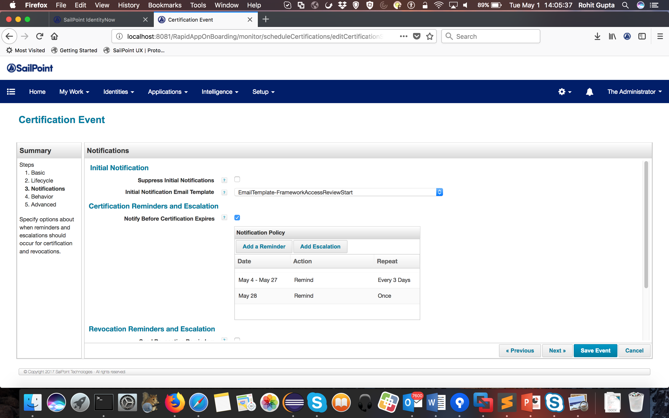

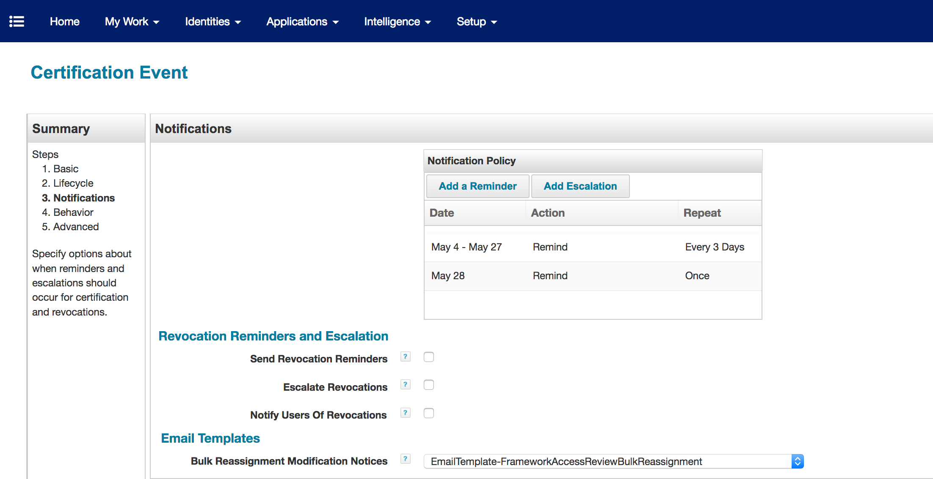

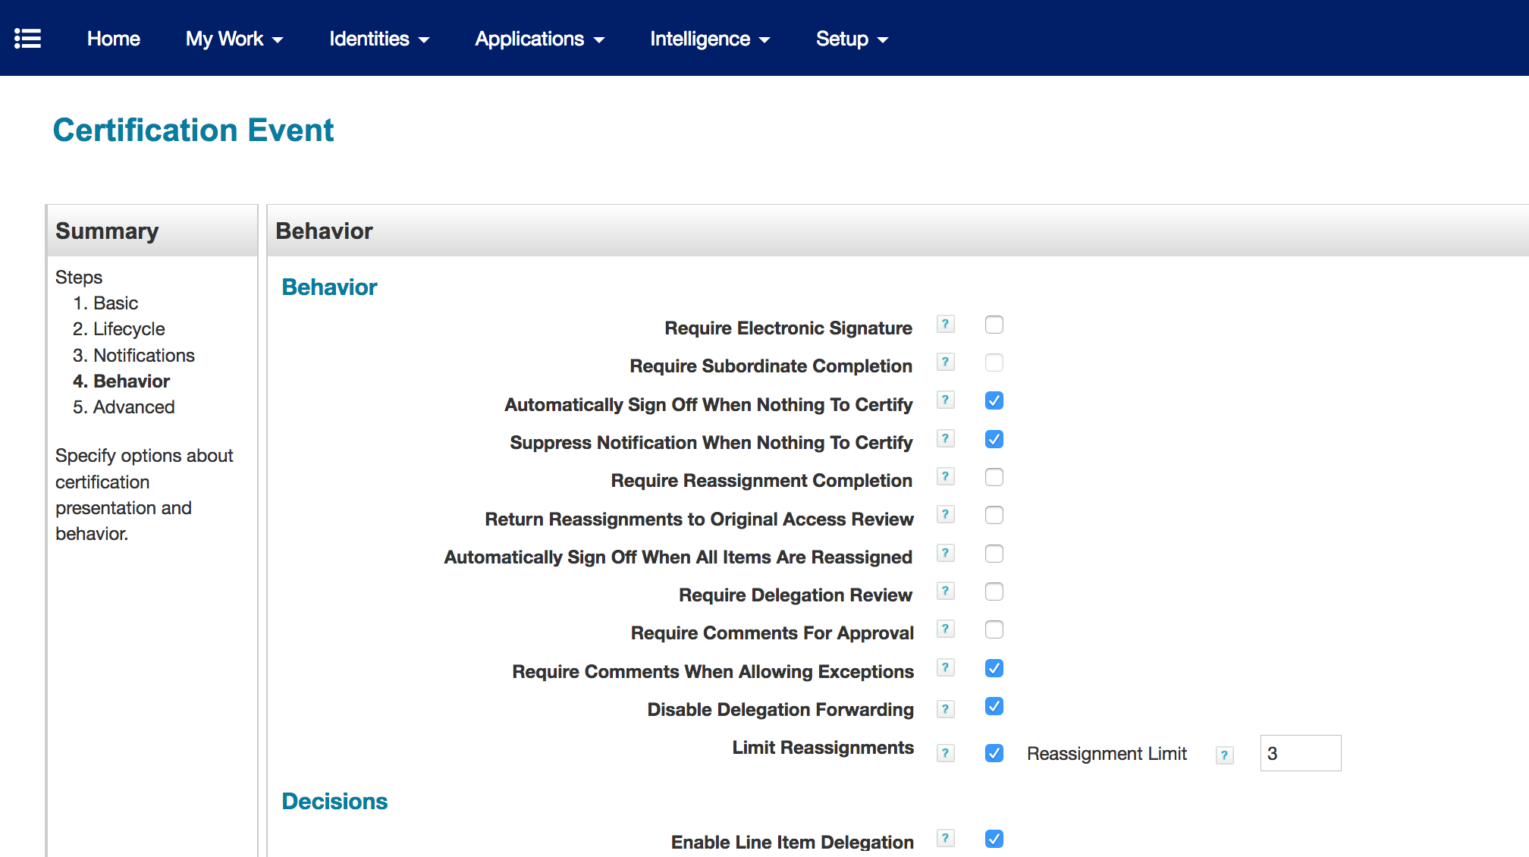
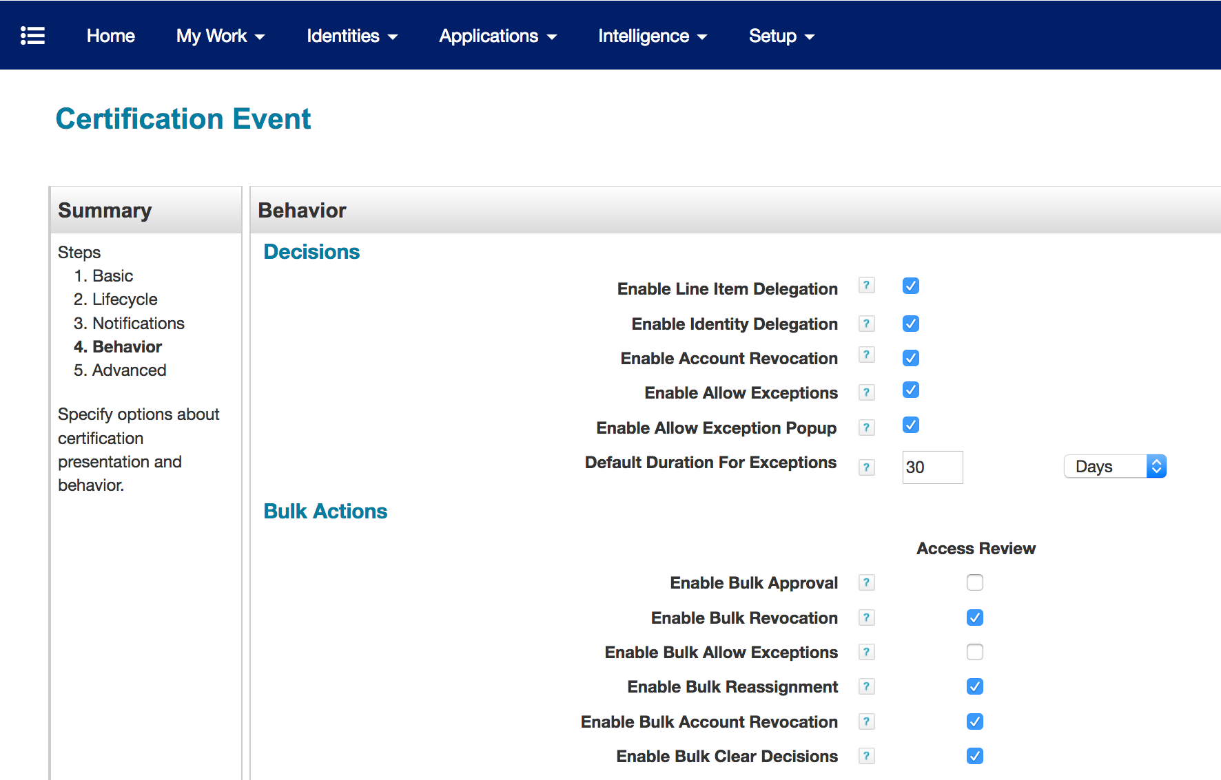

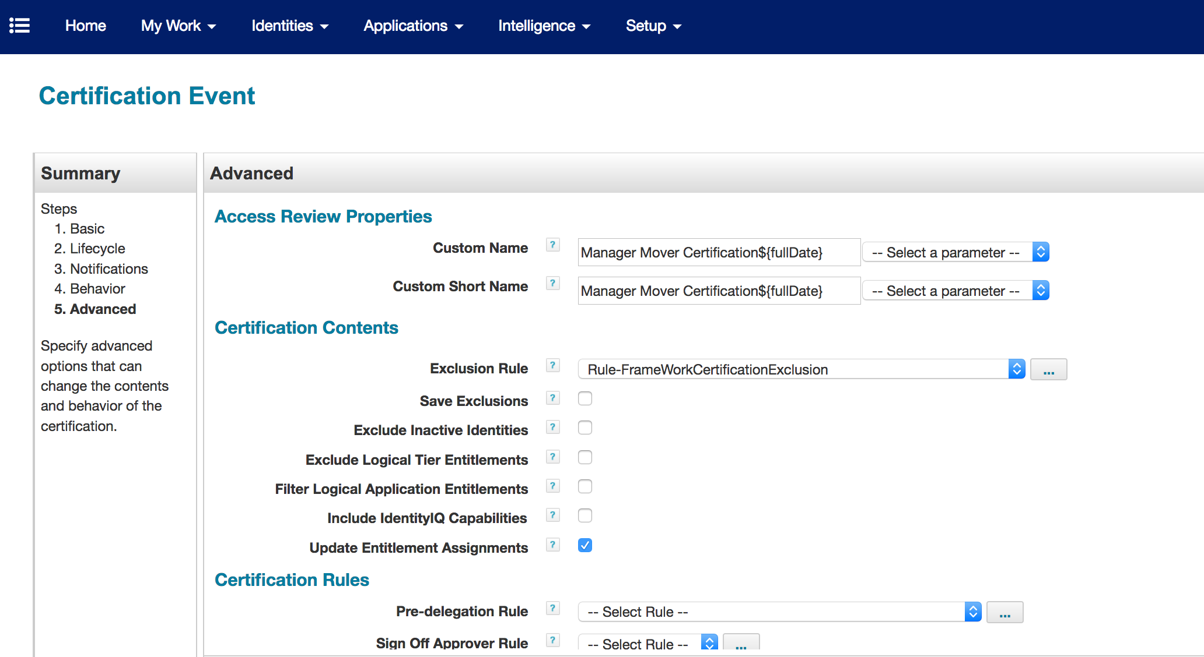

By default, challenge period is not enabled. If enabled, here is the screen shot of packaged challenge period email templates.

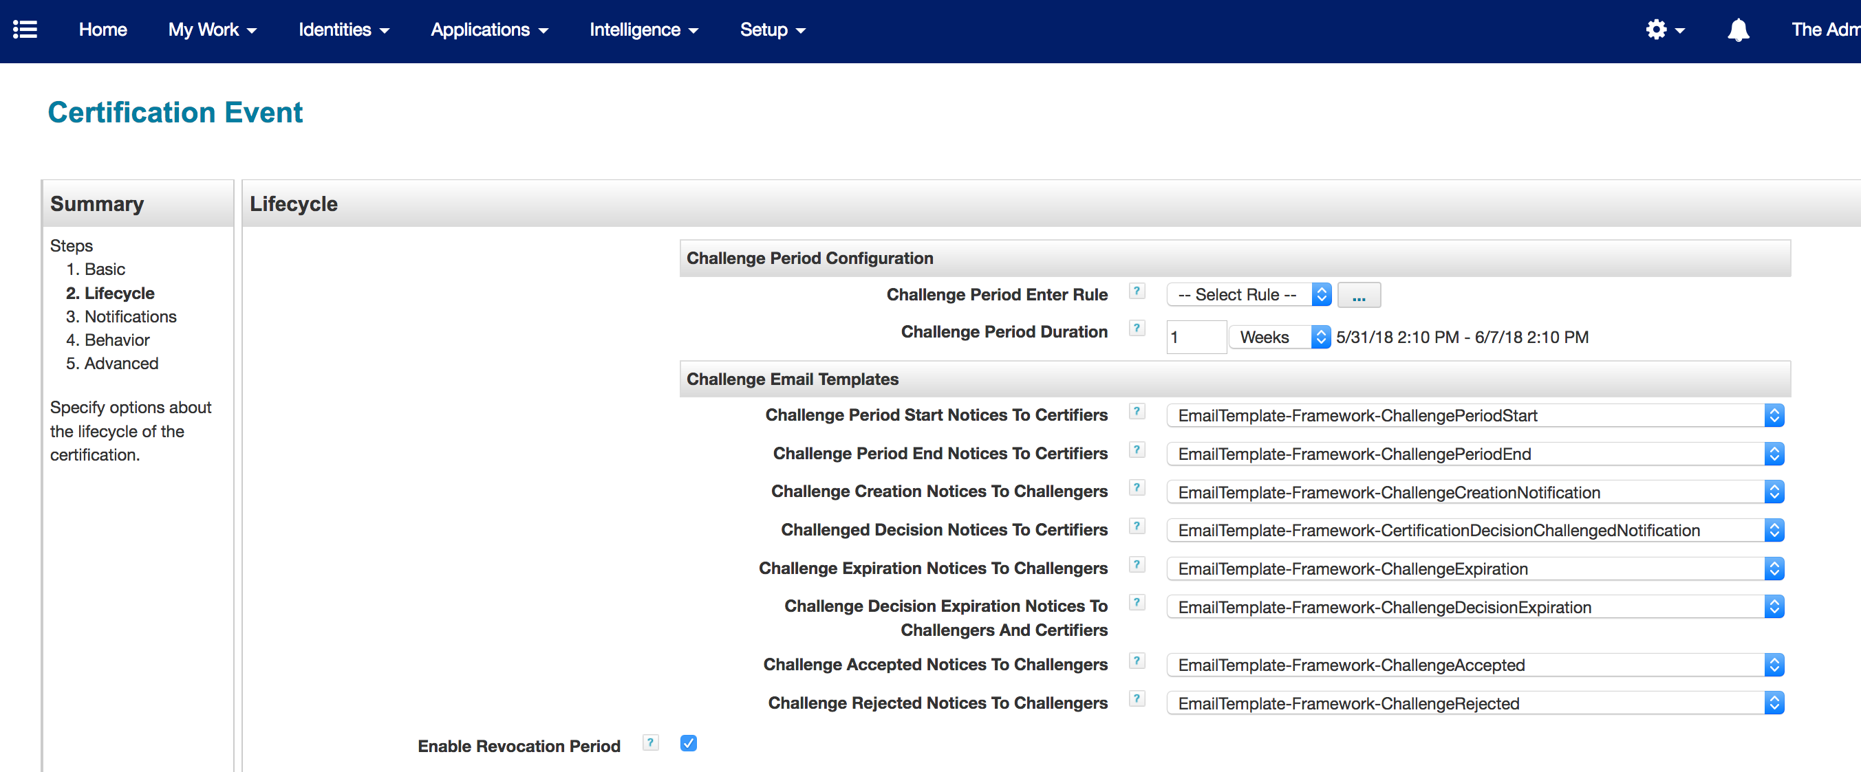

System Certification Item Rule
There is a certification item rule by the name “Rule-Framework-Certification-Item-Rule” that copies the logical application name from roles and entitlements to the certification item attribute “Custom1”. The name of the rule is “Rule-Framework-Certification-Item-Rule”.

Also, this rule copies the “entPrivileged” and “rolePrivileged” extended attribute values from entitlements and roles to the certification item attribute “Custom2”.

Application Inclusion

For Lifecycle Event, all the applications that are on an Identity Cube are included for Mover certification. By Default, all Logical Applications are included that are on an Identity Cube. Unless, they are excluded using QuickLink Accelerator Pack “Global Definition” QuickLink.

For Certification Event, applications configured for Mover needs to be manually selected and saved on the Certification Event.

Before Mover Certification
Applications may be configured to have “before mover” options. These options will be executed before the mover certification generation. If an error is encountered during execution, a mover certification will not be generated. If the “Move LDAP Account” option is selected, a target aggregation on an application is executed after the move of an account is completed. If “Extended Rule” option is selected, the rule name must be referenced on the application attribute “moverExtendedRule”. The display name of this attribute is “Before Mover Extended Rule”. This rule is executed per “Link” object of an application. In case there is a failure during rule execution mover certification wouldn’t be generated.

The following input parameters are passed to this kind of rule and can be used to build account requests per application. These account requests get merged into overall before mover provisioning plan.

Parameter Name | Description
identityName | Identity Name Being Processed
applicationName | Application Name Being Processed
nativeId | Native Id of Account Being Processed
secondaryAccount | “TRUE” value indicates secondary Link Object

Before Mover Only Primary Account
Any account that is not privileged is considered as primary account. When this option is checked, only primary account is moved If the “Rename / Move LDAP Account” option is selected.

Certification Exclusion Rule
For logical applications, the “Rule-FrameWorkCertificationExclusion” rule excludes the list of logical applications configured in the “Custom-Framework-Exclusion-Logical-BusinessApplications-PrivilegedAccess” custom object during certification. During the mover process, this rule is automatically selected.

Algorithm of Exclusion Rule
- Exclusions
  - Excludes Privileged Roles and Entitlements, if this is configured to be excluded in the custom artifact “Custom-Framework-Exclusion-Logical-BusinessApplications-PrivilegedAccess” (detected using extended attributes “entPrivileged” and “rolePrivileged”)
  - Excludes Application’s Birthright Roles and Entitlements (detected using an extended attribute “isBirthright”)
  - Excludes Assigned RBAC Roles (Assigned via assignment rules)
  - Excludes Logical Application Roles and Logical Application Entitlements for Infrastructure/ Technology Applications only if no logical application is defined on them (no value for an extended attribute “appName” on roles and no value for an extended attribute “entAppName” on entitlements)
  - Excludes Logical Application Roles and Logical Application Entitlements, if the logical application name does match the exclusion list
  - Excludes Logical Application Entitlement and Logical Application Role, if one of the logical application names separated by commas matches the exclusion list of logical applications
- Inclusions
  - Include All Business Application’s roles and entitlements (detected using Boolean extended attribute “busApp”)
    - A Role is included if it has at least one business application defined on profiles
  - Includes Business Application accounts with no entitlements
  - Includes Logical Application accounts with no entitlements, if the logical application name does not match the exclusion list of logical applications
  - Includes Logical Application Entitlement and Logical Application Role, if the logical application name does not match the exclusion list
  - Includes Policy Violation, if configured

Mover Process

This process starts with either a Workflow based Lifecycle Event or Certification based Certification Event. Workflow based event can be configured using the “Configure Triggers” QuickLink. It is based on the Identity Cube’s old and new attribute values.

This process can be kicked off manually by the Operations QuickLink “Process Identity Event”. This QuickLink is accessible to the “Operations” workgroup.

This workflow builds a provisioning plan based on existing accounts on an Identity. Here is the pseudo algorithm:
- Execute Before Mover Certification Option, Any Error, Exit
  - If the option is “Extended Rule”, execute the rule and merge the Account Request into Provisioning Plan
  - Process Attribute Synchronization Before Mover per Application, if checked
  - Please see Before Mover Certification
  - Process Joiner per Application, if checked
- Include all account applications for an Identity
  - See Certification Exclusion Rule
  - See Mover Certification Configuration
  - See Mover and Automated Mitigation Data Flow

Automated Mitigation Process
The pre-requisite for this process is the mover process completion. This is used to automatically revoke access that has been allowed by a manager for a certain time during the mover campaign.

This process starts with the Lifecycle event ”MANAGER CERTIFICATION ALLOW EXCEPTION FEATURE”. This event is packaged with Accelerator Pack.

Pseudo Algorithm on Lifecycle Event
- Get All Mitigation Expiration Work Items on an Identity
- Filter Only Expired Work Items
- If one of the expired Work Item doesn’t have the comment “MOVER EVENT PROCESSED”, kick off Automated Mitigation Workflow

The same workflow process can be kicked off manually by the Operations QuickLink “Process Identity Event”. This QuickLink is accessible to the “Operations” workgroup.

This workflow builds a revoke provisioning plan based on Identity’s expired mitigations that are from mover certification. Here is the pseudo algorithm:
- Build a Provisioning Plan to Remove Entitlements and Roles
- Accounts with no entitlements use the selected option from the “Automated Account Mitigation Options” attribute for an application
- See Mover and Automated Mitigation Data Flow

Mitigation Manager Notification
Manager Notification is sent out to the sponsor of the contractors or to the manager of employees during Mitigation Lifecycle Event. Sponsor on contractor is detected using extended attribute "ctrMgr".

If there is a requirement to cc this email, an extended rule can be used and referenced using Global Definition configuration “CC Email Rule” option.

Mover and Automated Mitigation Data Flow

